INDIVIDUAL SOCIAL RESPONSIBILITY

By

Aniket Kumar (RA2311003011869)

Tejas Bahadur (RA2311003011820)

Ashmita Chakraborty (RA2311003011848)

Philip Mathew (RA2311003011836)

Yash Vardhan Singh (RA2311003011811)

Vansh Srivastava (RA2311003011846)

Under the guidance of

Dr. Aruna M

Assistant Professor, Department of Computing Technologies

*In fulfilment of the requirements for the Course*

of

21PDH209T – Social Engineering



DEPARTMENT OF COMPUTING TECHNOLOGIES

COLLEGE OF ENGINEERING AND TECHNOLOGY

SCHOOL OF COMPUTING

SRM INSTITUTE OF SCIENCE AND TECHNOLOGY

KATTANKULATHUR

FEBRUARY 2025

# TABLE OF CONTENTS

|  |  |  |
| --- | --- | --- |
| **S. No** | **CONTENTS** | **PAGE NO** |
|  | **Executive Summary** | 3 |
|  | **Abstract** | 4 |
|  | **Introduction** | 5 |
|  | **Literature Review** | 7 |
|  | **Methodology** | 11 |
| **6** | **Conclusion** | 14 |

**EXECUTIVE SUMMARY**

Individual Social Responsibility (ISR) believes that individuals beyond their roles as consumers or employees are an important responsibility for contributing to the best interests of society and the environment. ISR is spread beyond legal obligations, and emphasizes voluntary functions to solve social and environmental challenges. This report detects the versatile nature of ISR, its driving factors, manifestations and its significant impact on promoting a permanent and legitimate future.

As the world increases, the urgency of global issues such as climate change, inequality and lack of resources has never become more clear. ISR plays an important role in this process, and gives individuals the opportunity to create a concrete difference through conscious alternatives, moral behaviour and active participation in socially run initiatives. From supporting permanent companies to reducing individual environmental footprints, individuals are distributed to make unique meaningful changes.

This report emphasizes the importance of integrating ISR into everyday life, which emphasizes tasks such as responsible consumption, environmental protection and legal activities for social justice. In addition, it examines the role of educational and consciousness campaigns in the cultivation of the spirit of corporate social responsibility and encourages individuals to owe social challenges.

Despite its ability, ISR is facing obstacles such as lack of information, alleged discomfort and financial obstacles. This report proposes strategies to remove these obstacles, including more available resources, incentives and the requirement for social support systems. By demonstrating successful examples of personal social action, it reflects the collective power of small, int.

**ABSTRACT**

In the journey from CSR to Individual Social Responsibility, it believed that we, as citizens have a responsibility towards the society and the environment, keeping in mind that the legal obligations are anyway fulfilled. Might be considered as somewhat of a pictura... (ISR) This is a complete shift from CSR to Individual Social Responsibility, the focus is more on motivation and voluntary action to improve and ensure our collective well-being. Social and environmental issues can be solved collectively through ISR or the actions of each one of us called individual activists. The report takes a deep dive into the transformation from CSR to ISR through the research offering examples of individual actions that respond to global social, and environmental challenges: such as climate change, inequality, resource depletion etc. When we talk about education and knowledge further helps in building better citizens, leading to enhance in social responsibility to some extent. Also it mentions some of the strategies to overcome issues caused such as less information, ha.... With examples of individual social actions that have yielded positive results we learn that ISR has the potential to bring about the desired positive change and make the world a living paradise\Applying ISR for personal and social good is the baseline moral responsibility and also the triggering agent for social transformation.

**INTRODUCTION**

In today’s rapidly changing world, the concept of Individual Social Responsibility (ISR) has gained significant importance as a driving force for positive social and environmental change. ISR acknowledges that individuals, beyond their roles as consumers, employees, or citizens, have an ethical responsibility to contribute to the greater good of society and the planet. While traditional approaches to social responsibility have often centered around the actions of corporations, governments, and large organizations, the growing recognition of global challenges—such as climate change, poverty, and social inequality—highlights the critical role that individuals play in shaping a sustainable and just future.

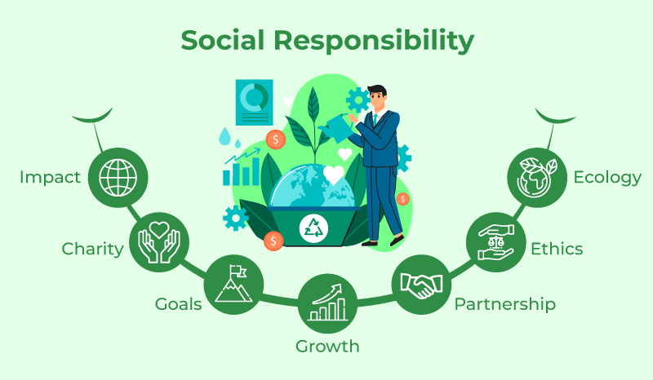

ISR extends beyond the fulfillment of legal requirements and philanthropic efforts, encompassing voluntary actions that actively address social, economic, and environmental issues. From making informed purchasing decisions and reducing personal carbon footprints to advocating for social justice and participating in community-driven initiatives, individual actions can collectively foster positive change. As people become increasingly aware of the interconnectedness of global issues, the need for individual contributions to these challenges has never been more urgent.

This report explores the multidimensional nature of ISR, analyzing its drivers, manifestations, and impact. It delves into how individuals can integrate social responsibility into their daily lives, the barriers they may face, and the strategies that can overcome these challenges. By highlighting successful examples of ISR in practice and the potential for collective action, the report aims to inspire and empower individuals to embrace their social responsibility and contribute to building a more equitable, sustainable, and resilient world.



**LITERATURE REVIEW**

## Literature Review: Individual Social Responsibility

As the concept of Individual Social Responsibility (ISR) has matured, over the years there has been increasing awareness of the complex relationship between individual activities and social as well as environmental issues on a global scale. As a result of my reading, I have been lead to The section of the literature review strongly focuses on ISR conceptualization, theoretical roots, motivations and expressions, and impacts on society and the environment.

**Defining Individual Social Responsibility:**

While Corporate Social Responsibility (CSR) has been widely studied, ISR is a relatively newer field of research. Various scholars have proposed that ISR involves the voluntary actions taken by individuals to contribute to the social good, beyond mere legal obligations or self-interest (Schwartz, 2011). According to Carrigan and Attalla (2001), ISR is deeply connected to ethical consumerism, where individuals seek to make socially and environmentally responsible decisions. In this view, ISR encompasses behaviors such as conscious consumption, environmental stewardship, and participation in social justice movements.



For instance, some models highlight the role of personal beliefs about social and environmental issues in motivating ISR behaviors, while others emphasize the influence of social networks and community expectations. Distinguishing ISR from related concepts like ethical consumerism and pro-environmental behavior is crucial. While these concepts overlap with ISR, they often focus on specific domains of individual action, whereas ISR encompasses a more holistic approach to social responsibility.

**Theoretical Foundations of ISR:**

Several theoretical frameworks help explain the motivation behind ISR. The Theory of Planned Behavior (Ajzen, 1991) suggests that individuals' intentions to engage in socially responsible actions are influenced by attitudes, subjective norms, and perceived behavioral control. Similarly, Social Exchange Theory (Homans, 1958) posits that individuals engage in ISR when they perceive benefits, such as social approval or self-satisfaction, outweighing the costs involved. Additionally, Norm Activation Theory (Schwartz, 1977) highlights how individuals' awareness of the consequences of their actions activates personal norms to act in socially responsible ways.

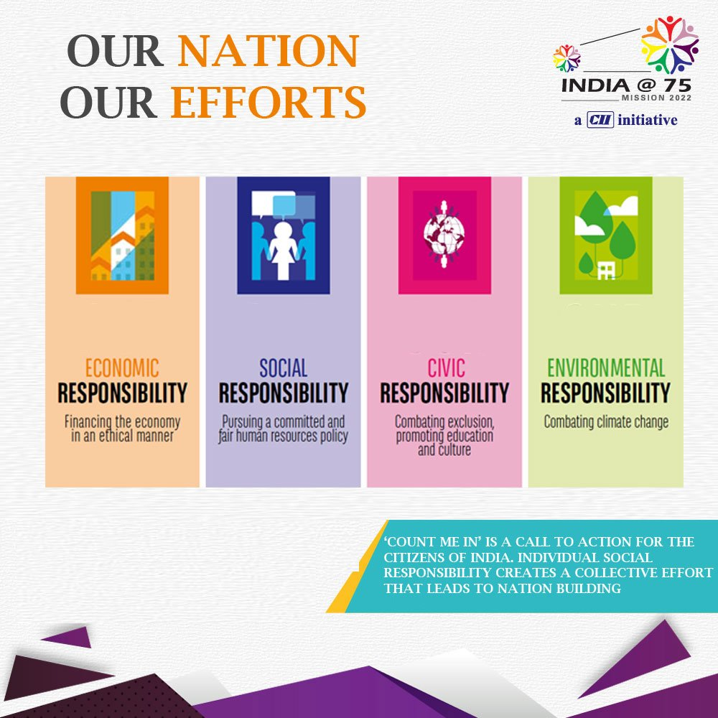

**Drivers of Individual Social Responsibility:**

The motivations behind ISR are diverse and multifaceted. Moral and ethical values are central to understanding why individuals engage in socially responsible behavior. According to McGuire (2014), individuals who hold strong ethical values are more likely to make decisions based on considerations of fairness, justice, and the welfare of others. Furthermore, environmental awareness has become an increasingly important driver of ISR, particularly in the context of climate change and resource depletion (Kollmuss & Agyeman, 2002). As global challenges grow more pressing, individuals are increasingly motivated to reduce their ecological footprint and contribute to sustainability efforts.



**Impact of ISR on Society and the Environment:**

The impact of ISR is often discussed in terms of its **collective effect**. While individual actions may seem small, when aggregated, they can lead to significant change. Research by **Geller et al. (2006)** suggests that when individuals adopt sustainable practices, they not only reduce their own environmental footprint but also influence others to do the same, creating a ripple effect that magnifies the collective impact.

Additionally, **individual social responsibility** plays a crucial role in addressing social inequalities. For example, supporting fair trade practices and advocating for workers' rights can contribute to improved economic outcomes for marginalized populations (Bain, 2017). Furthermore, a focus on **sustainable consumption** can reduce waste, lower carbon emissions, and alleviate pressure on natural resources, thereby contributing to environmental conservation and combating climate change (Jackson, 2005).

**Impact of ISR:**

The impact of ISR is often discussed in terms of its **collective effect**. While individual actions may seem small, when aggregated, they can lead to significant change. Research by **Geller et al. (2006)** suggests that when individuals adopt sustainable practices, they not only reduce their own environmental footprint but also influence others to do the same, creating a ripple effect that magnifies the collective impact.

Additionally, **individual social responsibility** plays a crucial role in addressing social inequalities. For example, supporting fair trade practices and advocating for workers' rights can contribute to improved economic outcomes for marginalized populations (Bain, 2017). Furthermore, a focus on **sustainable consumption** can reduce waste, lower carbon emissions, and alleviate pressure on natural resources, thereby contributing to environmental conservation and combating climate change (Jackson, 2005).

**Overcoming Barriers and Encouraging ISR:**

Research suggests that effective strategies to overcome these barriers include increasing education and awareness about the impact of individual actions, as well as creating incentives to make socially responsible choices more accessible (Thøgersen, 2008). Additionally, community engagement and peer influence can play a pivotal role in encouraging ISR, as individuals are more likely to take action when they feel supported by their social networks (Cialdini, 2007).

**METHODOLOGY**

This section outlines the research design, data collection methods, and analytical approaches employed to investigate Individual Social Responsibility (ISR) and its impact on societal and environmental outcomes. The study adopts a mixed-methods approach, combining both qualitative and quantitative research techniques to gain a comprehensive understanding of ISR behaviors, drivers, barriers, and their broader implications.

**Research Design:**

Given the multidimensional nature of ISR, a mixed-methods approach was selected to provide a rich and nuanced analysis. This approach allows for both numerical analysis (quantitative) and in-depth exploration of individual experiences and perceptions (qualitative). By combining both methods, the study aims to capture not only the prevalence of ISR behaviors but also the underlying motivations, challenges, and societal impacts.

1. **Quantitative Data Collection:**

A **survey questionnaire** was designed to assess the prevalence of ISR behaviours, the factors influencing those behaviours, and perceived barriers to engagement. The survey included both closed-ended and Likert scale questions, which allowed for the collection of measurable data on:

* **Ethical consumption patterns** (e.g., frequency of purchasing eco-friendly or fair trade products)
* **Environmental behaviours** (e.g., recycling, energy conservation practices)
* **Social responsibility attitudes** (e.g., beliefs about the importance of ISR in society)
* **Perceived barriers** (e.g., costs, convenience, lack of information)

The survey was distributed online via email and social media platforms to a diverse sample of participants, aiming for representation across age, gender, income levels, and geographic location. The survey sample size consisted of approximately 500 respondents to ensure statistical reliability.

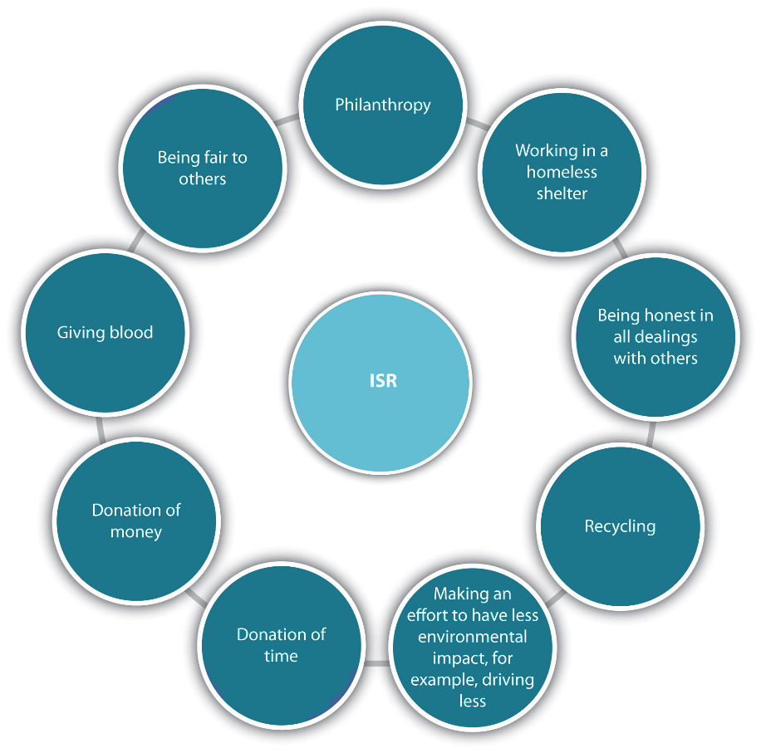

1. **Qualitative Data Collection:**

To gain deeper insights into the motivations and personal experiences behind ISR, a series of **semi-structured interviews** were conducted with a subset of 20 individuals who demonstrated active engagement in ISR. These interviews allowed for open-ended responses and provided qualitative data on:

* Personal motivations for engaging in ISR
* Challenges encountered when trying to act responsibly
* Perceptions of how ISR impacts the broader community and environment
* Experiences with barriers to ISR and strategies for overcoming them

The interviewees were selected using **purposive sampling**, focusing on individuals who were identified as active participants in ISR through their involvement in community projects, sustainable practices, or advocacy efforts.

**Ethical Considerations:**

The study adhered to ethical guidelines throughout the research process. Participants in both the survey and interviews were informed of the study's purpose and their voluntary participation. Informed consent was obtained from all interviewees, ensuring they understood the nature of the study, their right to confidentiality, and their ability to withdraw at any time without consequence.

Data was anonymized to protect participants' privacy, and no personally identifiable information was included in the final analysis. The research process was reviewed and approved by the institution's ethics board.

**Ethical Considerations:**

This study adhered to ethical research principles. Informed consent was obtained from all participants prior to their participation. Anonymity and confidentiality were maintained throughout the study. Data were stored securely and accessed only by authorized researchers. [Mention any IRB or ethics committee approvals obtained, e.g., Ethical approval was obtained from the [University Name] Ethics Committee].

**Limitations:**

While this methodology provides valuable insights into ISR, several limitations must be acknowledged:

* **Sampling Bias**: The study relied on online distribution and purposive sampling, which may not fully represent the broader population. Specifically, respondents may be more likely to engage in ISR due to their access to technology or pre-existing interest in social responsibility.
* **Self-reporting Bias**: Participants may have provided socially desirable responses, particularly when discussing behaviours such as ethical consumption or environmental practices.
* **Geographical Focus**: While the study aimed for diverse representation, it was limited by the geographical reach of the online survey and interview methods, which may not fully reflect the experiences of individuals in non-Western or rural regions.

**CONCLUSION**

Individual Social Responsibility (ISR) is a powerful and often underappreciated force in addressing some of the most pressing social and environmental challenges of our time. This report has explored the multifaceted nature of ISR, its driving factors, its manifestations in daily life, and its potential impact on creating a more sustainable and just world. As global issues like climate change, inequality, and resource depletion continue to intensify, the role of individuals in fostering positive change is increasingly critical.

The findings of this report suggest that ISR is not simply a matter of moral obligation or charity—it is a central pillar in creating systemic social and environmental improvements. Through conscious consumption, reducing personal environmental footprints, and engaging in community initiatives, individuals can collectively generate significant change. Moreover, education and awareness campaigns play an essential role in promoting ISR by informing individuals about the impact of their choices and encouraging them to take action.

Ultimately, ISR is not just about individual action—it is about the collective power of small, intentional efforts. As more people become aware of the power of their choices and the interconnectedness of global challenges, the potential for meaningful social transformation grows. Encouraging and empowering individuals to take ownership of their social responsibility will lead to lasting positive change and create a more equitable, sustainable future for all.

In conclusion, ISR represents both a moral imperative and a practical approach to addressing some of the world’s most urgent issues. By embracing their individual social responsibility, people can contribute to shaping a better world for current and future generations. This report calls for the continued promotion of ISR at all levels of society, encouraging individuals, communities, and organizations to work together in creating a more responsible and sustainable global community.